Summary: Graphical Representation of Motion

1. Importance of Graphs
Graphs provide a clear visual method to present data. In Physics, they show relationships between quantities such as distance vs. time or velocity vs. time. They help analyze uniform, non-uniform, accelerated, or rest motion. To describe the motion of an object, we can use line graphs. In this case, line graphs show dependence of one physical quantity, such as distance or velocity, on another quantity, such as time.

2. Distance–Time Graphs
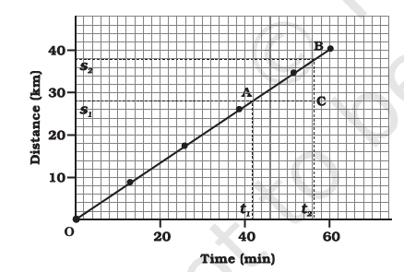
- Axes: Time → x-axis; Distance → y-axis.
We know that when an object travels equal distances in equal intervals of time, it moves
with uniform speed. This shows that the distance travelled by the object is directly
proportional to time taken. Thus, for uniform speed, a graph of distance travelled against time is a straight line.
Speed = slope of line = (s2 - s1) / (t2 - t1).
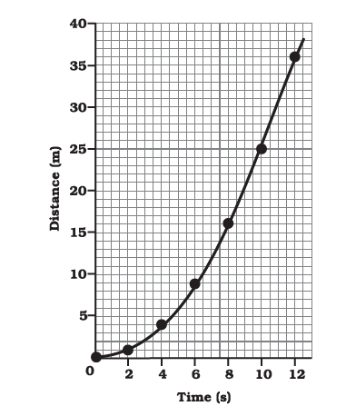
Note that, you can also use the term uniform velocity in place of uniform speed if you take the magnitude of displacement equal to the distance travelled by the object along the y-axis.
- Non-uniform Motion: Graph is curved (non-linear).

3. Velocity–Time Graphs
- Axes: Time → x-axis; Velocity → y-axis.
- Uniform Velocity: Straight horizontal line. Displacement = area under graph.
- Uniform Acceleration: Straight sloping line. Displacement = rectangle + triangle area.
- Non-uniform Acceleration: Graph can be curved or irregular.

4. Key Examples and Activities
- Uniform Acceleration: Car velocity increases equally every 5s → straight sloping line.
- Distance from Graphs: Area under v–t graph = displacement. Rectangle → uniform velocity; Rectangle + triangle → uniform acceleration.
- Non-uniform Acceleration: Decreasing velocity (sloping down) or irregular variation.
-Activity:
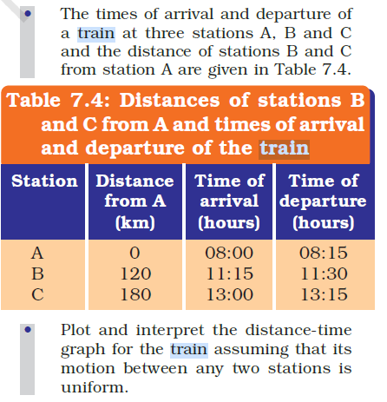

5. Essential Takeaways
1. Distance–time graphs: straight line = uniform, curve = non-uniform.
2. Slope of distance–time graph = speed.
3. Velocity–time graphs: horizontal = constant velocity, sloping = uniform acceleration, curve = non-uniform acceleration.
4. Area under velocity–time graph = displacement.
5. Graphs make motion data easier to analyze than tables.

